STANDARD FORMAT OF “LEHENGA DESCRIPTION”


For Online Selling Products
Design Name: TEEN KERI
Product Colours NO.: A2
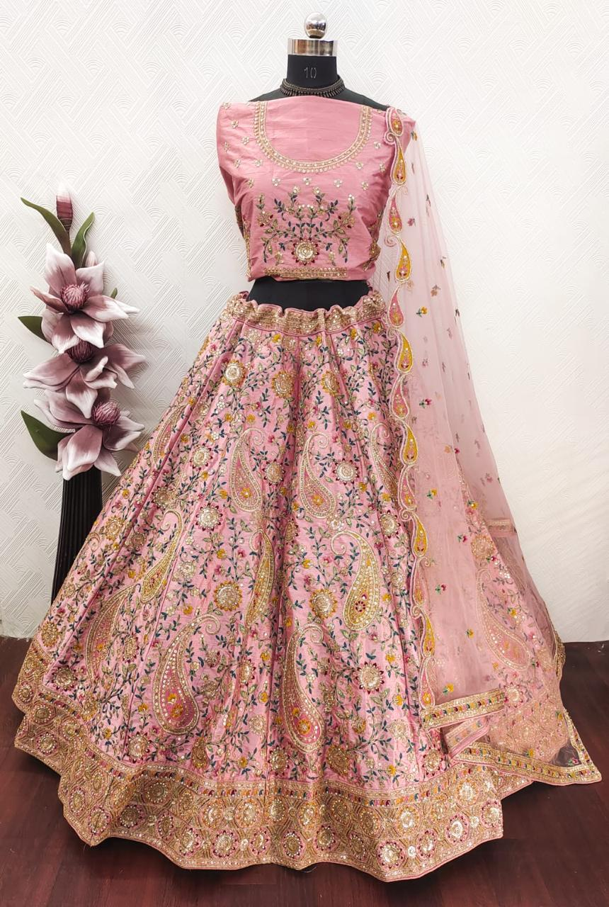.
Particulars | Details
Lehenga Fabric | Italian Silk
Blouse Fabric | Italian Silk
Dupatta Fabric | Net
Work Type | Jari, Jarkan & Thread embroidery Work
Colour | Pink
Pattern | Heavy Girlish, Bridal Designer - Lehenga
Stitching Type | Semi-Stitched (Can be customized up to 44")
Occasion | Wedding, Reception, Engagement & Festive Wear
Fit Type | Regular Fit
Care Instructions | Dry Clean Only
Package Contents | 1 Lehenga, 1 Blouse Piece, 1 Dupatta

KEY HIGHLIGHTS
- Crafted from premium Italian silk for a rich and elegant drape
- Features heavy Girlish lehenga work with Jari, Thread & Jarkan detailing
- Comes with a soft net dupatta for a graceful bridal appearance
- Perfect for receptions, festive events, and special functions
- Semi-stitched design supports easy customization and ideal fitting
- Lightweight material ensures comfort for long celebrations
- Combines modern bridal style with fine traditional craftsmanship

